SRI CHANDRASEKHARENDRA SARASWATHI VISWA MAHAVIDYALAYA

(UNIVERSITY ESTABLISHED under section 3 of UGC Act 1956)

ENATHUR, KANCHIPURAM – 631 561



DATA STRUCTURES AND ALGORITHMS
LABORATORY RECORD

Name : S.HARINHI

Reg. No : 112534076

Class : I YEAR BCA

Subject : UCAF252T40 – DSA Lab

SRI CHANDRASEKHARENDRA SARASWATHI

VISWA MAHAVIDYALAYA
(University Established under section 3 of UGC Act 1956)



BONAFIDE CERTIFICATE

This is to Certify that this is the bonafide record of work done by Mr. S. HARINHI with Reg. No 112534076 of I Year BCA in the Data Structures and Algorithms Lab during the year 2026.

Staff-in-charge Head of the Department

Submitted for the Practical Examination held on ________________________

Internal Examiner External Examiner.

INDEX

S.No. | Date | Title | Page No. | Signature
1 | 06 Feb 2026 | Program to Search an Element in the Array. | 01
2 | 13 Feb 2026 | Program to Search an Element In the Array using Binary Search. | 05
3 | 20 Feb 2026 | Program to Sort an Array using Bubble Sort. | 10
4 | 27 Feb 2026 | Program to Sort an Array using Selection Sort. | 13
5 | 06 Feb 2026 | Program to Sort an Array using Insertion Sort. | 17
6 | 13 Mar 2026 | Program to Implement a Stack Using Arrays. | 20
7 | 20 Mar 2026 | Program to Implement a Queue Using Arrays | 26
8 | 27 Mar 2026 | Program to Implement a Stack using Linked List | 33
9 | 03 Apr 2026 | Program to Implement a Queue using Linked List | 38

1 | Program to Search an Element In the Array | 06 Feb 2026

AIM:
Program to Search an Element in the Array using Linear Search.

ALGORITHM:
Step 1: Start.
Step 2: Declare the counter variable (i), array size (n), element to search found.
Step 3: Read = n, i = 0
Step 4: Read arr[i]
Step 5: increment i (i++)
Step 6: if (i<n) goto step 4.
Step 7: Read element to search (search).
Step 8: i = 0
Step 9: if arr[i] ! = Search goto step 12.
Step 10: found = 1.
Step 11: print “Element found at index = i” go to step 15.
Step 12: i++
Step 13: if i < n go to step 9.
Step 14: if found not equal to 1, print “Element not found”.
Step 15: stop.

FLOW CHART:

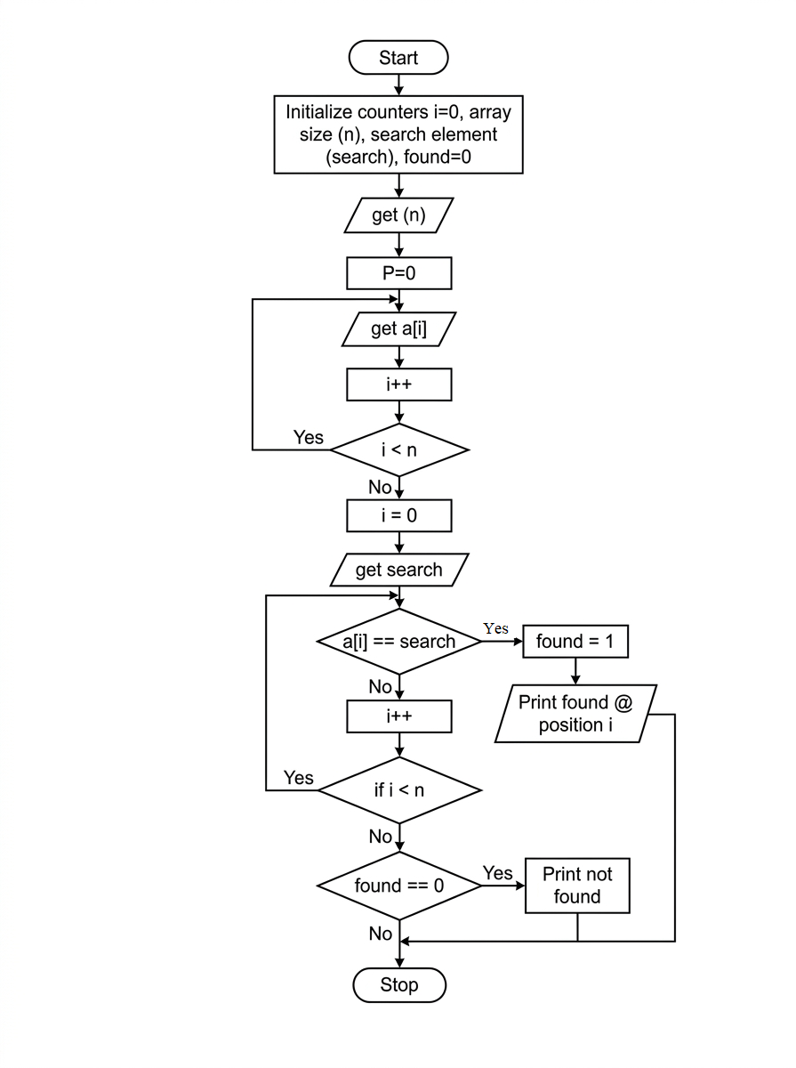
i=0

SOURCE CODE:
https://github.com/Harinhi26/DSA-lab/blob/main/ArraySearch.c

#include <stdio.h>
int main()
{
int n, i, search, found = 0;
// Input number of elements in the array
printf(“Enter number of elements in the array: “);
scanf(“%d”, &n);
int arr[n];
// Input array elements
printf(“Enter elements of the array: \n”);
for(i= 0; i< n; i++) {
scanf(“%d”, &arr[i]);
}
// Input the element to search
printf(“Enter element to search: “);
scanf(“%d”, &search);
// Linear search
for(i = 0; i< n; i++)
{
if(arr[i] == search)
{
found = 1;
printf(“Element %d found at index %d.\n”, search, i);
break;
}
}
// If element is not found
if(!found)
{
printf(“Element %d not found in the array.\n”, search);
}
return 0;
}

SAMPLEOUTPUT:

Enter number of elements in the array: 5
Enter elements of the array:
6
3
8
5
2
Enter element to search: 8
Element 8 found at index 2.
NEGATIVE I/O
Enter number of elements in the array: 5
Enter elements of the array:
6
3
8
5
2
Enter element to search: 10
Element 10 not found in the array

2 | Program to Search an Element In the Array using Binary Search | 13 Feb 2026

AIM:
Program to Search an Element in the Array using Binary Search.

ALGORITHM:
Step 1: start
Step 2: declare no of elements (n) elements to search (key)
Step 3: initialization array with n(arr[n])
Step 4: i=0
Step 5: get arr[i]
Step 6: i++
Step 7: if i<n goto step 5,else continue
Step 8: read element to search(key)
Step 9: result = binary search(arr,n,key)
Step 10: if (result!=1)
Step 11: print element found at position(result)else
Print element not found
Step 12: stop

ALGORITHM FOR BINARY SEARCH:
Step 1: int low=o, high=n-1
Step 2: if low(<=high)
Step 3: mid=(low+high)/2
Step 4: if (arr[mid]==key)
Return mid
Step 5: else if (arr[mid]<key)
Low=mid+1
Else
High+mid-1
Step 6: goto step 2
Step 7: return-1

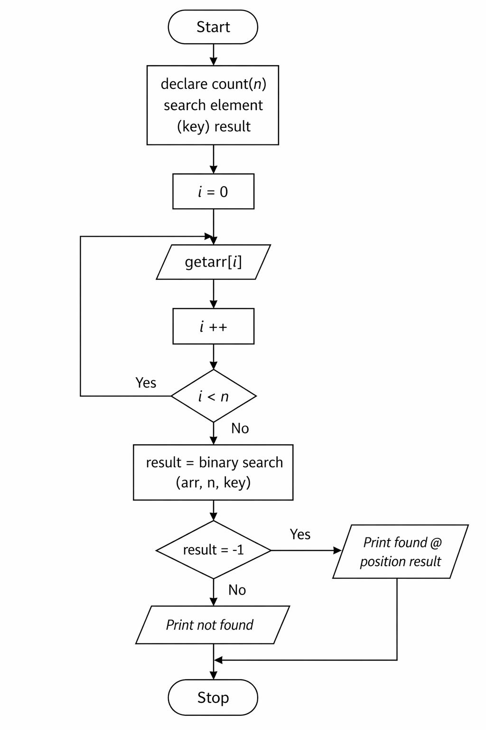
FLOW CHART:
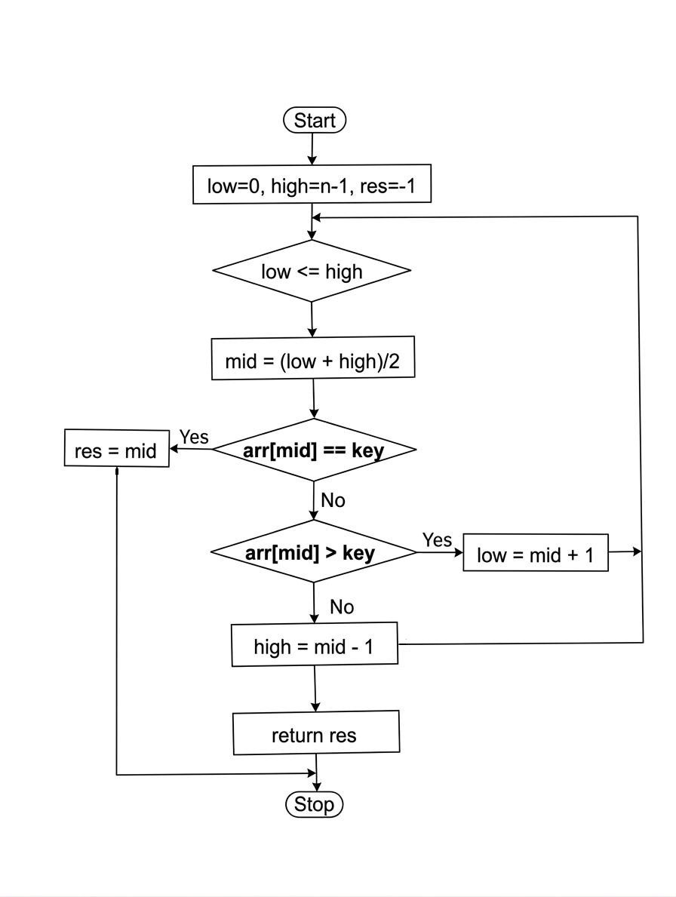
res= -1
Yes
No
Binarysearch(int arr[ ], int n, int key)

SOURCE CODE:
https://github.com/Harinhi26/DSA-lab/blob/main/BinarySearch.c
#include<stdio.h>
int binarysearch(int arr[],int n, int key)
{
int low=0,high=n-1,mid;
while(low<=high)
{
mid=(low+high)/2;
if (arr[mid]==key)
return mid;
//element found
else if(arr[mid]<key)
low=mid+1;
//search right half
else
high=mid-1;
//search left half
}
return 1;
//element not found
}
int main()
{
int n,key,result;
printf(“enter number of element:”);
scanf(“%d”,&n);
int arr[n];
printf(“enter %d sorted element:\n”,n);
int i;
for(i=0;i<n;i++){
scanf(“%d”,&arr[i]);
}
printf(“enter element to search:”);
scanf(“%d”,&key);
result = binarysearch(arr, n, key);
if(result!=-1)
printf(“element found at index %d \n”,result);
else
printf(“element not found \n”);
return 0;
}

SAMPLE OUTPUT:
Enter number of elements: 5
Enter 5 sorted elements:
11
12
13
14
15
Enter element to search: 14
Element found at index 3

3 | Program to Sort an Array using Bubble Sort | 20 Feb 2026

AIM:
Program to Sort an Array using Bubble Sort.

ALGORITHM:
Step 1: Start the program
Step 2: Read the number of elemnt n
Step 3: Declare an array arr[n]
Step 4: Input n elements into the array
Step 5: for i=0 to n-2
Step 6: for j=0 to n-i-2
Step 7: if arr[j]>arr[j+1]
Swap arr[j] and arr[j+1]
Temp=arr[j]
Arr[j]=arr[j+1]
Arr[j+1]=temp
Step 8: Print the sorted array
Step 9: Stop

FLOW CHART:

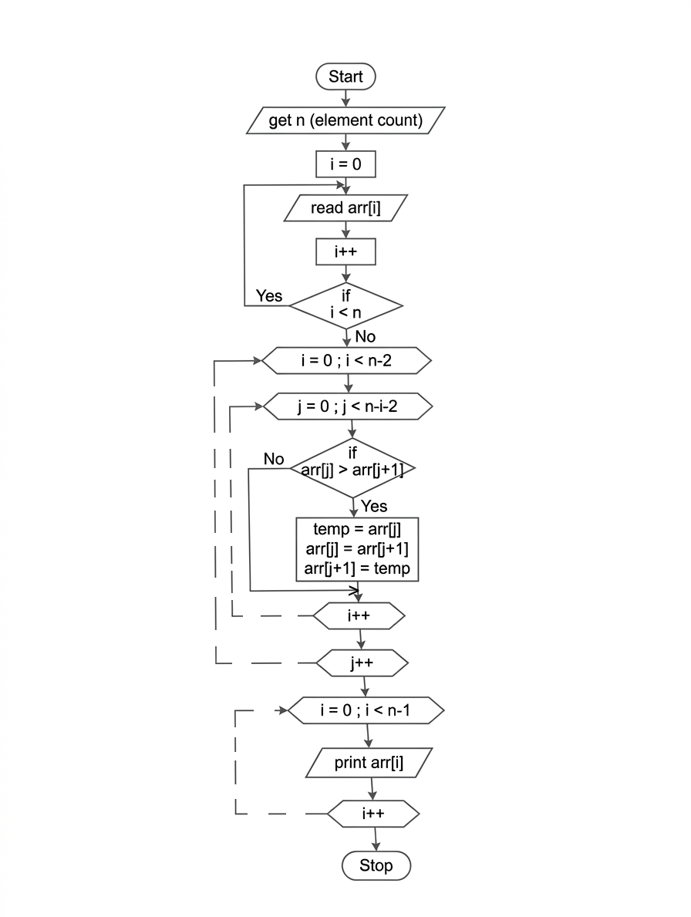

SOURCE CODE :
https://github.com/Harinhi26/DSA-lab/blob/main/BubbleSort.c

#include<stdio.h>
int main()
{
int n,temp;
int i,j;
printf(“enter number of element:”);
scanf(“%d”,&n);
int arr[n];
printf(“enter %d elements:\n”,n);
for(i=0;i<n;i++)
scanf(“%d”,&arr[i]);
//bubble sort logic
for(i=0;i<n;i++)
{
for(j=0;j<n;j++)
{
if(arr[j]>arr[j+1])
{
temp=arr[j];
arr[j]=arr[j+1];
arr[j+1]=temp;
}
}
}
printf(“sorted array:\n”);
for(i=0;i<n;i++)
printf(“%d”,arr[i]);
return 0;
}

SAMPLE OUTPUT:
Enter number of element:5
Enter 5 element:
25
32
95
65
23
Sorted array
23 25 32 65 95
4 | Program to Sort an Array using Selection Sort | 27 Feb 2026

AIM:
Program to Sort an Array using Selection Sort.

ALGORITHM:
Step 1: start
Step 2: declare element count (n),
Step 3: get n
Step 4: declare arr [n]
Step 5: get arr [i]
Step 6: i++
Step 7: repeat from step 5 till i<n
Step 8: I = 0
Step 9 : minindex = i
Step 10: j = i+1
Step 11: if arr [i]<arr
Step 12: temp = arr [i]
arr[i] = arr[minindex]
arr[minindex] = temp
Step 13: j++
Step 14: repeat from step 11 till j<n
Step 15: i++
Step 16: repeat from step 9 till i<n-1
Step 17: stop I = 0
Step 18: print arr [i]
Step 19: i++
Step 20: repeat from step 18 till i<n
Step 21: stop

FLOW CHART:
Start
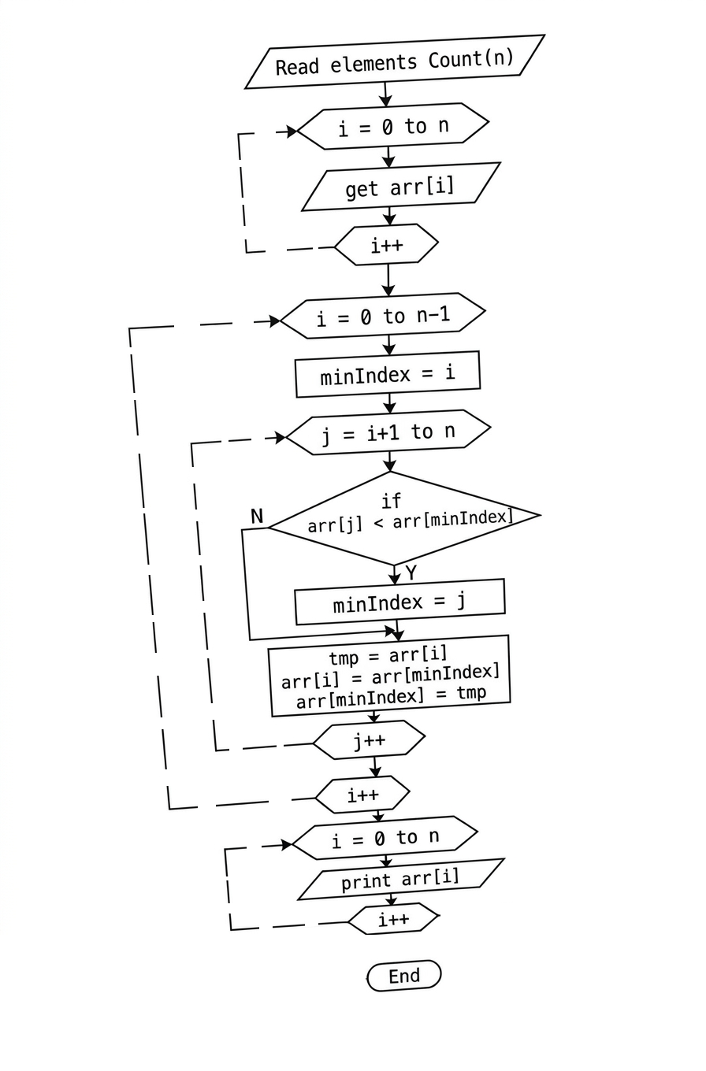

SOURCE CODE:
https://github.com/Harinhi26/DSA-lab/blob/main/SelectionSort.c

#include <stdio.h>
int main()
{
int n, temp, minindex;
printf(“enter number of elements: “);
scanf(“%d”, &n);
int arr[n];
printf(“enter %d elements:\n”, n);
for (int i = 0; i < n; i++)
scanf(“%d”, &arr[i]);
// selection sort logic
for (int i = 0; i < n – 1; i++)
{
minindex = i;
for (int j = i + 1; j < n; j++)
{
if (arr[j] < arr[minindex])
minindex = j;
}
// swap
temp = arr[i];
arr[i] = arr[minindex];
arr[minindex] = temp;
}
printf(“sorted array:\n”);
for (int i = 0; i < n; i++)
printf(“%d “, arr[i]);
return 0;
}

OUTPUT:
Enter number of elements: 6
Enter 6 elements:
12
14
11
22
20
19
Sorted array:
11 12 14 19 20 22

5 | Program to Sort an Array using Insertion Sort. | 06 Feb 2026

AIM:
Program to Sort an Array using Insertion Sort.

ALGORITHM:
Step 1: Start
Step 2: Read the number of elements (n)
Step 3: Declare an array of size n, arr[n]
Step 4: Read array elements iteratively
○ for i = 0 to n-1 do:
- Prompt user: “Enter element i+1”
- Read arr[i] from user input
Step 5: Sort the array using Insertion Sort
○ for i = 1 to n-1 do:
- key = arr[i]
- j = i – 1
- Compare and shift elements:
- while j >= 0 and arr[j] > key do:
- move arr[j] one position right: arr[j + 1] = arr[j]
- j = j – 1
- insert the key at its correct position:
  - arr[j + 1] = key
- repeat for the next element (i = i + 1)
Step 6: Display the sorted array
for i = 0 to n-1 do:
print arr[i]
Step 7: End

FLOW CHART:

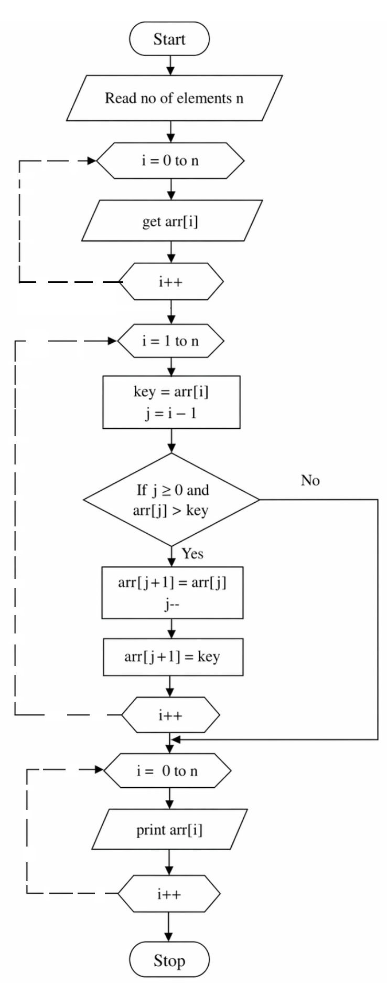

SOURCE CODE:
https://github.com/Harinhi26/DSA-lab/blob/main/InsertionSort.c

#include <stdio.h>
int main()
{
int n, key, j;
printf(“enter number of elements: “);
scanf(“%d”, &n);
int arr[n];
printf(“enter %d elements:\n”, n);
for (int i = 0; i < n; i++)
scanf(“%d”, &arr[i]);
// insertion sort logic
for (int i = 1; i < n; i++)
{
key = arr[i];
j = i – 1;
while (j >= 0 && arr[j] > key)
{
arr[j + 1] = arr[j];
j--;
}
arr[j + 1] = key;
}
printf(“sorted array:\n”);
for (int i = 0; i < n; i++)
printf(“%d “, arr[i]);
return 0;
}

SAMPLE OUTPUT:
Enter number of elements: 6
Enter 6 elements:
12
14
11
22
20
19
Sorted array:
11 12 14 19 20 22
6 | Program to Implement a Stack Using Arrays | 13 March 2026

AIM:
Program to Implement a Stack Using Arrays.

ALGORITHM:
Step 1: Start – Begin program execution.
Step 2: Initialize Stack – Define a stack of size MAX (5).
Step 3: Initialize top – Set top = -1 to indicate the stack is empty.
Step 4: Display Main Menu – Show options: 1. Push 2. Pop 3. Display 4. Exit.
Step 5: Read User Choice – Read the choice from the user.
● If choice = 1, go to Push Operation Steps.
● If choice = 2, go to Pop Operation Steps.
● If choice = 3, go to Display Operation Steps.
● If choice = 4, go to Exit Operation Steps.
● Otherwise, print “Invalid choice” and return to Step 4 (Display Main Menu).

Push ( ) Operation Steps (Choice = 1)
Step P1: Check Stack Overflow – If top == MAX – 1, print “Stack Overflow” and return to step 4 (Display MainMenu).
Step P2: Read Item – Read the element to push from the user.
Step P3: Increment top – top = top + 1.
Step P4: Assign Stack Element – stack[top] = item.
Step P5: Print Success Message – Print “Element pushed successfully” and return to Step 4 (Display Main Menu).

Pop( ) Operation Steps (Choice = 2)
Step O1: Check Stack Underflow – If top == -1, print “Stack Underflow” and return toStep4 (Display Main Menu).
Step O2: Print Popped Element – Print stack[top].
Step O3: Decrement top – top = top – 1 and return to Step 4 (Display Main Menu).

Display( ) Operation Steps (Choice = 3)
Step D1: Check if Stack is Empty – If top == -1, print “Stack is empty” and return to Step 4 (Display Main Menu).
Step D2: Loop Through Stack – For I = top down to 0, print stack[i].
Step D3: Return to Main Menu – Go back to Step 4 (Display Main Menu).

Exit( ) Operation Steps (Choice = 4)
Step E1: Print Exit Message – Print “Exiting program”.
Step E2: End – Program execution ends.

FLOWCHART:
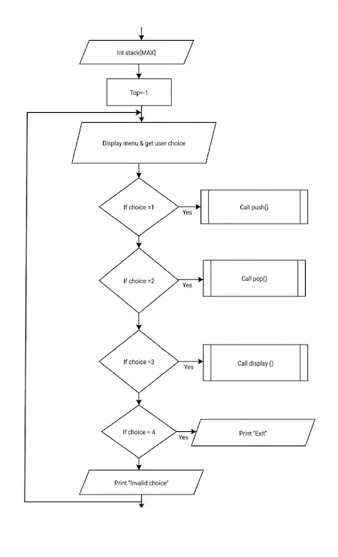
No
No
No
No
Stop
Start
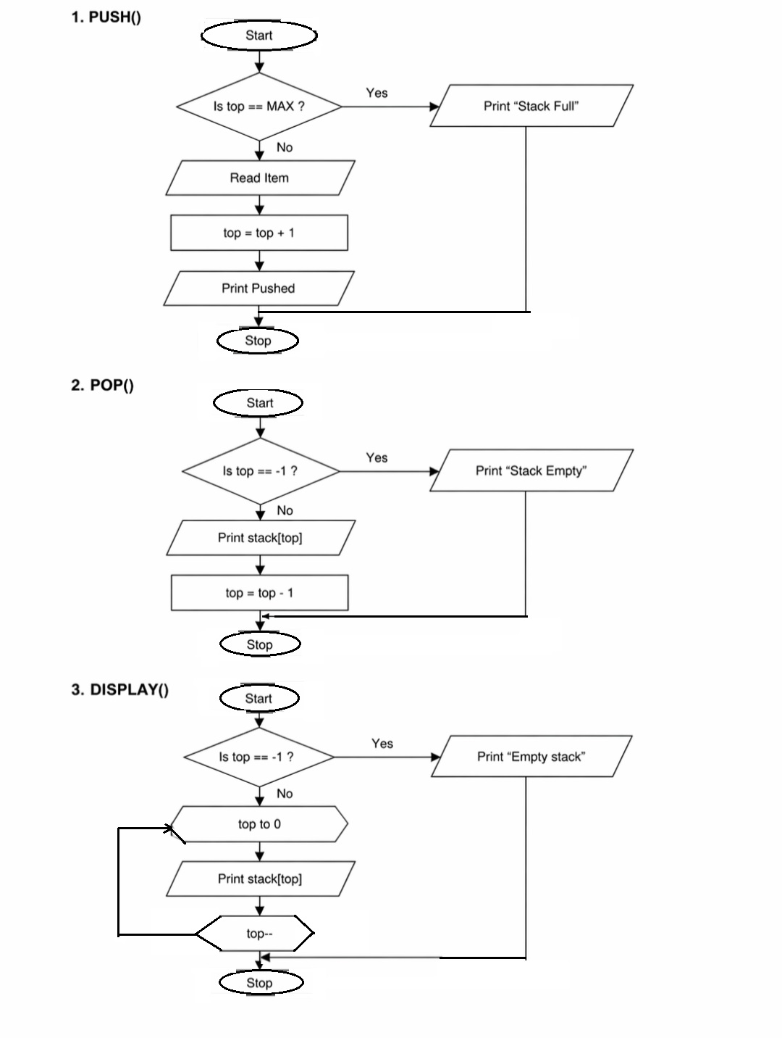
top++, arr[top]=item

SOURCE CODE:
https://github.com/Harinhi26/DSA-lab/blob/main/ImplementStackUsingArrays.c

#include <stdio.h>
#define max
int stack[max];
int top = -1;
// push operation
void push()
{
int item;
if (top == max – 1)
{
printf(“stack overflow!\n”);
return;
}
printf(“enter element to push: “);
scanf(“%d”, &item);
stack[++top] = item;
printf(“element pushed successfully.\n”);
}
// pop operation
void pop()
{
if (top == -1)
{
printf(“stack underflow!\n”);
return;
}
printf(“popped element: %d\n”, stack[top--]);
}
// display stack elements
void display()
{
if (top == -1)
{
printf(“stack is empty.\n”);
return;
}
printf(“stack elements:\n”);
for (int i = top; i >= 0; i--)
printf(“%d\n”, stack[i]);
}
int main()
{
int choice;
do
{
print(“\n--- stack menu ---\n”);
printf(“1. push\n2. pop\n3. display\n4. exit\n”);
printf(“enter your choice: “);
scanf(“%d”, &choice);
switch (choice)
{
case 1:
push();
break;
case 2:
pop();
break;
case 3:
display();
break;
case 4:
printf(“exiting program.\n”);
break;
default:
printf(“invalid choice!\n”);
}
} while (choice != 4);

return 0;
}

SAMPLE OUTPUT:
--- Stack Menu ---
1. Push
2. Pop
3. Display
4. Exit
Enter your choice: 1
Enter element to push: 12
Element pushed successfully.

--- Stack Menu ---
1. Push
2. Pop
3. Display
4. Exit
Enter your choice: 1
Enter element to push: 13
Element pushed successfully.
--- Stack Menu ---
1. Push
2. Pop
3. Display
4. Exit
Enter your choice: 3
Stack elements:
13
12

--- Stack Menu ---
1. Push
2. Pop
3. Display
4. Exit
Enter your choice: 2
Popped element: 13

--- Stack Menu ---
1. Push
2. Pop
3. Display
4. Exit
Enter your choice: 3
Stack elements:
12

--- Stack Menu ---
1. Push
2. Pop
3. Display
4. Exit
Enter your choice:
4
Exiting program.

7 | Program to Implement a Queue Using Arrays | 20 March 2026

AIM:
Program to Implement a Queue Using Arrays

ALGORITHM:
Step 1: Start – Begin program execution.
Step 2: Initialize Queue – Define a queue of size MAX (5).
Step 3: Initialize front and rear – Set front = -1 and rear = -1 to indicate the queue is empty.
Step 4: Display Main Menu – Show options: 1. Enqueue 2. Dequeue 3. Display 4. Exit.
Step 5: Read User Choice – Read the choice from the user.
● If choice = 1, go to Enqueue Operation Steps.
● If choice = 2, go to Dequeue Operation Steps.
● If choice = 3, go to Display Operation Steps.
● If choice = 4, go to Exit Operation Steps.
● Otherwise, print “Invalid choice” and return to Step 4 (Display Main Menu).

Enqueue( ) Operation Steps (Choice = 1)
Step E1: Check Queue Overflow – If rear == MAX – 1, print “Queue Overflow” and return to Step 4 (Display Main Menu).
Step E2: Read Item to Insert – Read the element to enqueue from the user.
Step E3: Check if Queue Empty – If front == -1, set front = 0.
Step E4: Increment rear – rear = rear + 1.
Step E5: Assign Queue Element – queue[rear] = item.
Step E6: Print Success Message – Print “Element inserted successfully” and return to Step 4 (Display Main Menu).

Dequeue( ) Operation Steps (Choice = 2)
Step D1: Check Queue Underflow – If front == -1 or front > rear, print “Queue Underflow” and return to Step 4(Display Main Menu).
Step D2: Print Deleted Element – Print queue[front].
Step D3: Increment front – front = front + 1 and return to Step 4 (Display Main Menu).

Display( ) Operation Steps (Choice = 3)
Step DS1: Check if Queue is Empty – If front == -1 or front > rear, print “Queue is empty” and return to Step 4(Display Main Menu).
Step DS2: Loop Through Queue – For I = front to rear, print queue[i].
Step DS3: Return to Main Menu – Go back to Step 4 (Display Main Menu).

Exit Operation Steps (Choice = 4)
Step X1: Print Exit Message – Print “Exiting program”.
Step X2: End – Program execution ends.

FLOWCHART:
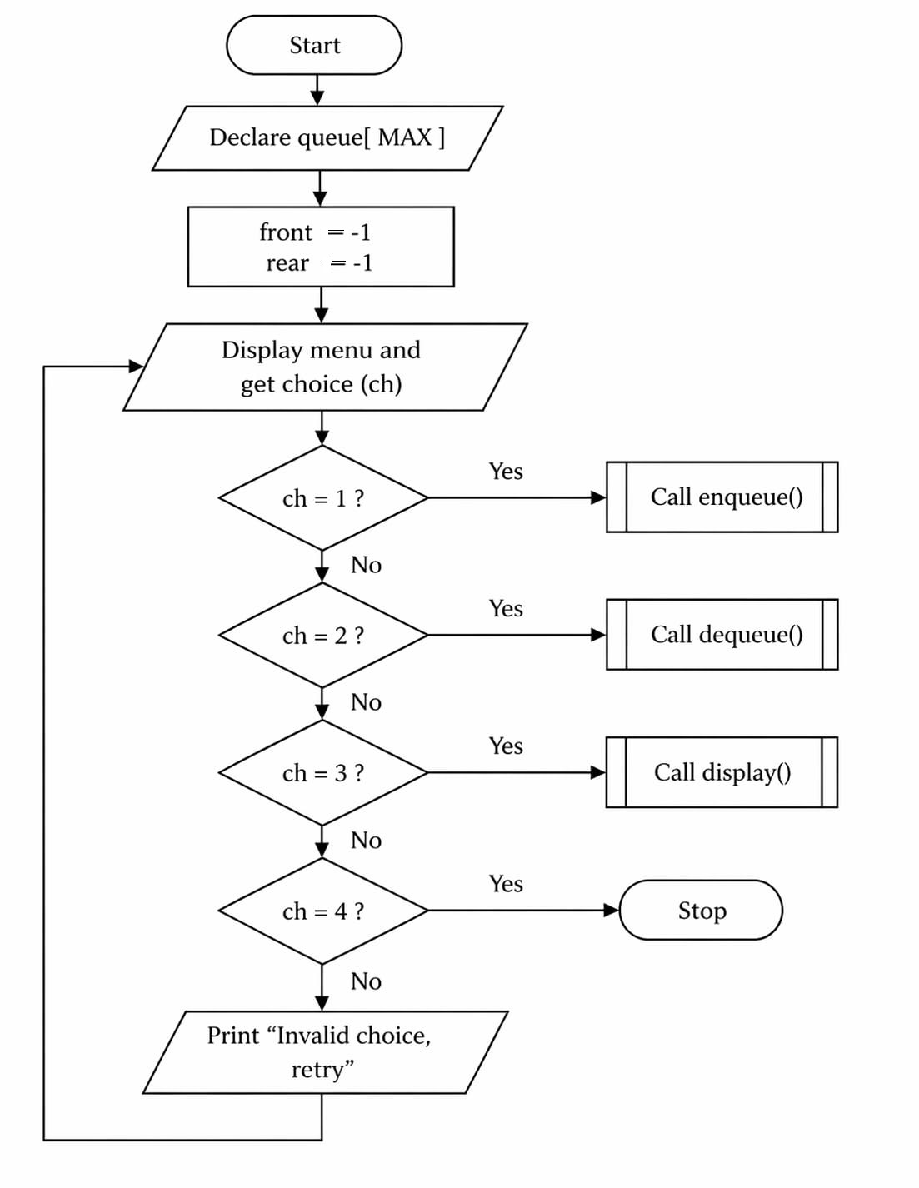
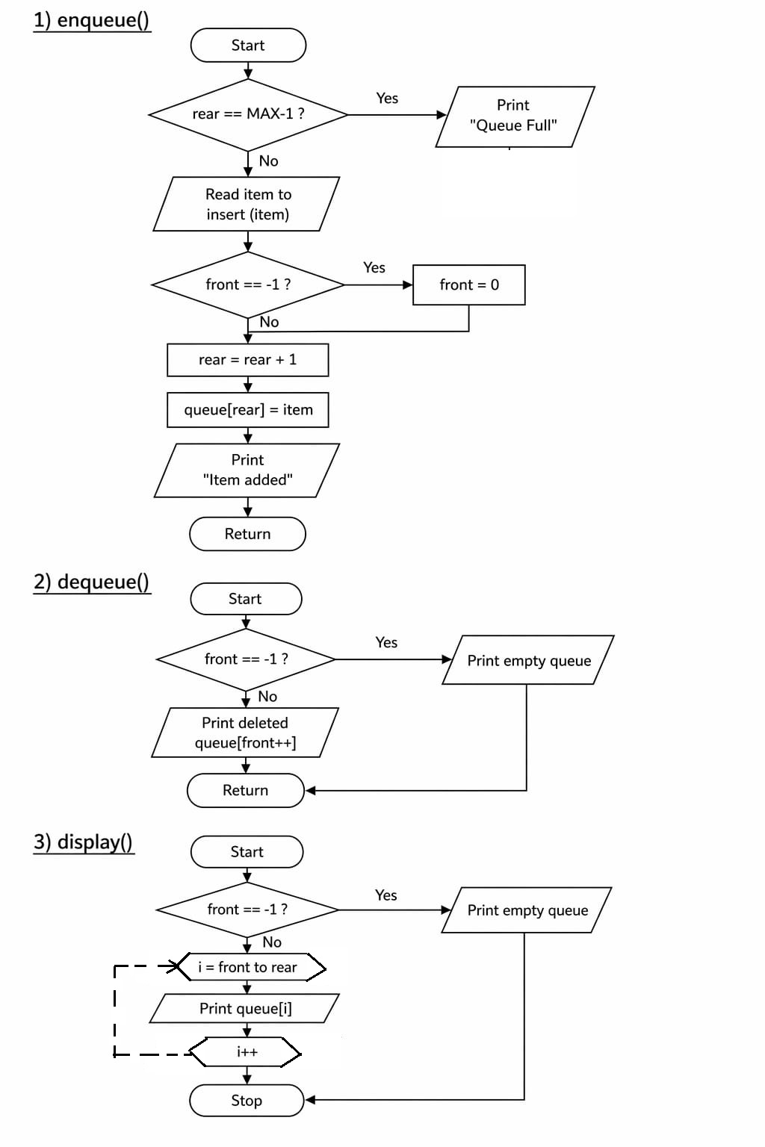
SOURCE CODE:
https://github.com/Harinhi26/DSA-lab/blob/main/ImplementQueueUsingArrays.c

#include <stdio.h>
#define max 5
int queue[max];
int front = -1, rear = -1;
// insert element (enqueue)
void enqueue()
{
int item;
if (rear == max – 1)
{
printf(“queue overflow!\n”);
return;
}
printf(“enter element to insert: “);
scanf(“%d”, &item);
if (front == -1)
front = 0;
queue[++rear] = item;
printf(“element inserted successfully.\n”);
}
// delete element (dequeue)
void dequeue()
{
if (front == -1 || front > rear)
{
printf(“queue underflow!\n”);
return;
}
printf(“deleted element: %d\n”, queue[front++]);
}
// display queue elements
void display()
{
if (front == -1 || front > rear)
{
printf(“queue is empty.\n”);
return;
}
printf(“queue elements:\n”);
for (int i = front; i <= rear; i++)
printf(“%d “, queue[i]);
printf(“\n”);
}
int main()
{
int choice;
do
{
printf(“\n--- queue menu ---\n”);
printf(“1. enqueue\n2. dequeue\n3. display\n4. exit\n”);
printf(“enter your choice: “);
scanf(“%d”, &choice);
switch (choice)
{
case 1:
enqueue();
break;
case 2:
dequeue();
break;
case 3:
display();
break;
case 4:
printf(“exiting program.\n”);
break;
default:
printf(“invalid choice!\n”);
}
} while (choice != 4);
return 0;
}

SAMPLE OUTPUT:
--- Queue Menu ---
1. Enqueue
2. Dequeue
3. Display
4. Exit
Enter your choice: 1
Enter element to insert: 16
Element inserted successfully.

--- Queue Menu ---
1. Enqueue
2. Dequeue
3. Display
4. Exit
Enter your choice: 1
Enter element to insert: 23
Element inserted successfully.

--- Queue Menu ---
1. Enqueue
2. Dequeue
3. Display
4. Exit
Enter your choice: 1
Enter element to insert: 36
Element inserted successfully.

--- Queue Menu ---
1. Enqueue
2. Dequeue
3. Display
4. Exit
Enter your choice: 3
Queue elements:
16 23 36

--- Queue Menu ---
1. Enqueue
2. Dequeue
3. Display
4. Exit
Enter your choice: 3
Queue elements:
16 23 36

--- Queue Menu ---
1. Enqueue
2. Dequeue
3. Display
4. Exit
Enter your choice: 2
Deleted element: 16

--- Queue Menu ---
1. Enqueue
2. Dequeue
3. Display
4. Exit
Enter your choice: 3
Queue elements:
23 36

--- Queue Menu ---
1. Enqueue
2. Dequeue
3. Display
4. Exit
Enter your choice: 4
Exiting program.

8 | Program to Implement a Stack using Linked List | 27 Apr 2026

AIM:
Program to Implement a Stack using Linked List

ALGORITHM:

1. Initialization
- Define a structure node with two parts: data (integer) and next (pointer to the next node).
- Initialize a global pointer top to NULL.

2. Push Operation
- Allocate memory for a newnode.
- If memory allocation fails, print "Heap Overflow" and return.
- Read the element to be pushed.
- Set newnode->data = item.
- Set newnode->next = top (Link the new node to the current top).
- Update top = newnode (Move the top pointer to the new node).

3. Pop Operation
- Check if top == NULL. If yes, print "Stack Underflow" and return.
- Create a temporary pointer temp and set temp = top.
- Print the data of the element being popped (temp->data).
- Update top = top->next (Move the top pointer to the next node).
- free(temp) to release the memory.

4. Display Operation
- Check if top == NULL. If yes, print "Stack is empty" and return.
- Create a temporary pointer temp and set it to top.
- While temp is not NULL:
  - Print temp->data.
  - Move temp to the next node (temp = temp->next).

5. Main Menu Loop
- Repeat the following until the user chooses to exit (Choice 4):
  - Display options: 1. Push, 2. Pop, 3. Display, 4. Exit.
  - Read user choice.
  - Execute the corresponding function based on choice.

FLOWCHART:
1.push
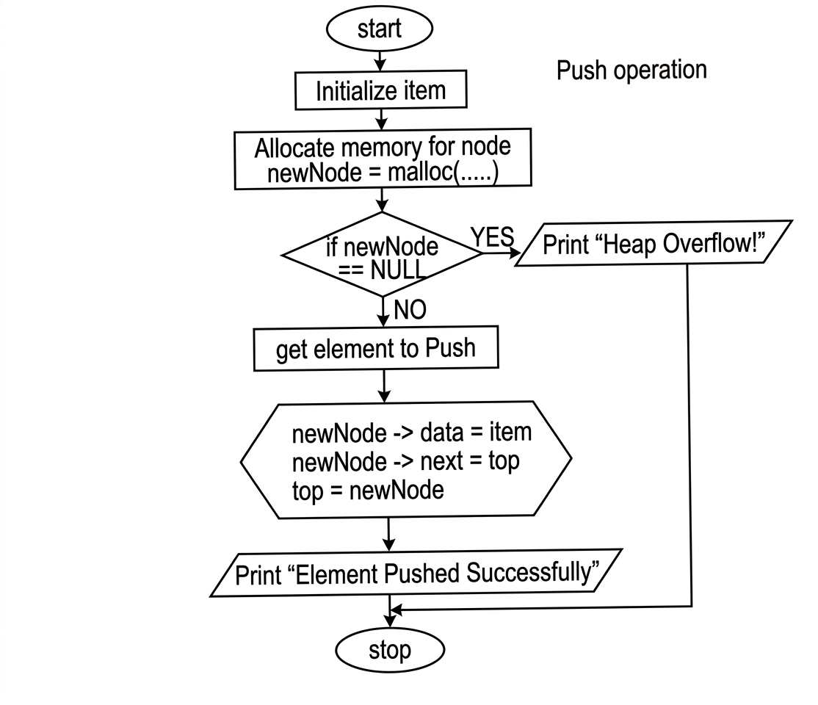
2.pop
STO[
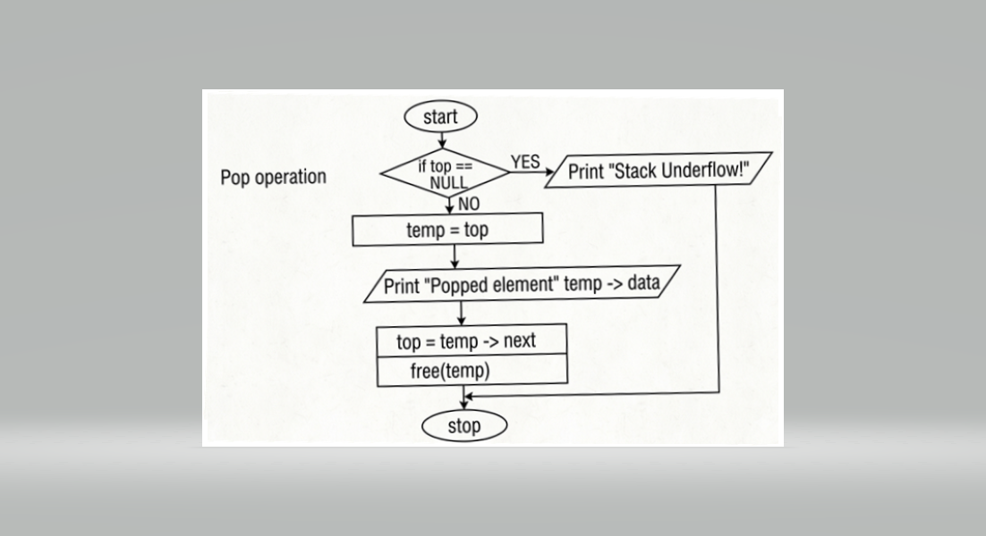

3.Display
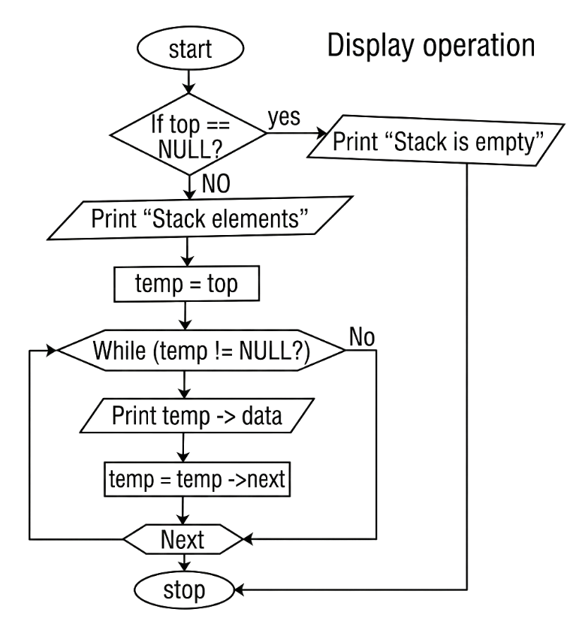

Main Function
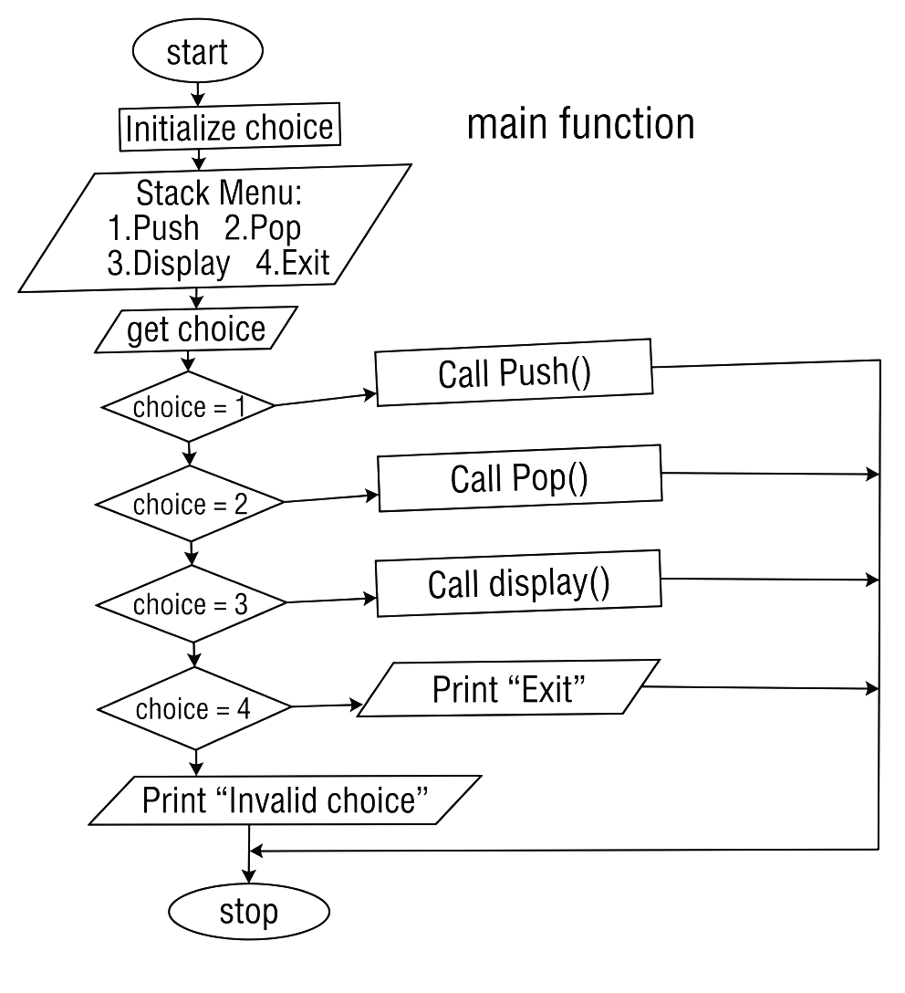

SOURCE CODE:
https://github.com/Harinhi26/dsalab/blob/main/Impliment Stack using Linked List.c
#include <stdio.h>
#include <stdlib.h>
// structure for stack node
struct node
{
int data;
struct node *next;
};
struct node *top = null;
// push operation
void push()
{
int item;
struct node *newnode;
newnode = (struct node *)malloc(sizeof(struct node));
if (newnode == null)
{
printf(“heap overflow!\n”);
return;
}
prints(“enter element to push: “);
scanf(“%d”, &item);
newnode->data = item;
newnode->next = top;
top = newnode;
printf(“element pushed successfully.\n”);
}
// pop operation
void pop()
{
struct node *temp;
if (top == null)
{
printf(“stack underflow!\n”);
return;
}
temp = top;
printf(“popped element: %d\n”, temp->data);
top = temp->next;
free(temp);
}
// display stack
void display()
{
struct node *temp;
if (top == null)
{
printf(“stack is empty.\n”);
return;
}
printf(“stack elements:\n”);
temp = top;
while (temp != null)
{
printf(“%d\n”, temp->data);
temp = temp->next;
}
}
int main()
{
int choice;
do
{
printf(“\n--- stack menu ---\n”);
printf(“1. push\n2. pop\n3. display\n4. exit\n”);
printf(“enter your choice: “);
scanf(“%d”, &choice);
switch (choice)
{
case 1:
push();
break;
case 2:
pop();
break;
case 3:
display();
break;
case 4:
printf(“exiting program.\n”);
break;
default:
printf(“invalid choice!\n”);
}
} while (choice != 4);
return 0;
}

SAMPLE OUTPUT:
--- Stack Menu ---
1. Push
2. Pop
3. Display
4. Exit
Enter your choice: 1
Enter element to push: 23
Element pushed successfully.

--- Stack Menu ---
1. Push
2. Pop
3. Display
4. Exit
Enter your choice: 1
Enter element to push: 35
Element pushed successfully.

--- Stack Menu ---
1. Push
2. Pop
3. Display
4. Exit
Enter your choice: 1
Enter element to push: 36
Element pushed successfully.

--- Stack Menu ---
1. Push
2. Pop
3. Display
4. Exit
Enter your choice: 3
Stack elements:
36
35
23

--- Stack Menu ---
1. Push
2. Pop
3. Display
4. Exit
Enter your choice: 3
Stack elements:
36
35
23

--- Stack Menu ---
1. Push
2. Pop
3. Display
4. Exit
Enter your choice:
2
Popped element: 36

--- Stack Menu ---
1. Push
2. Pop
3. Display
4. Exit
Enter your choice: 3
Stack elements:
35
23

--- Stack Menu ---
1. Push
2. Pop
3. Display
4. Exit
Enter your choice: 4
Exiting program.

9 | Program to Implement a Queue using Linked List | 03 Apr 2026

AIM:
Program to Implement a Queue using Linked List

ALGORITHM:

1. Initialization
- Define a structure node with data and a pointer next.
- Initialize two global pointers: front = NULL and rear = NULL.

2. Enqueue Operation (Insertion)
- Allocate memory for a newNode.
- If memory allocation fails, print "Heap Overflow" and exit the function.
- Read the value to be inserted into newNode->data.
- Set newNode->next = NULL.
- Check if Queue is Empty: If rear == NULL:
  - Set both front and rear to newNode.
- Else (Queue has elements):
  - Link the current rear's next to the new node: rear->next = newNode.
  - Update the rear pointer: rear = newNode.
- Print "Element inserted successfully."

3. Dequeue Operation (Deletion)
- Check if Queue is Empty: If front == NULL:
  - Print "Queue Underflow" and return.
- Create a temporary pointer temp and set temp = front.
- Print the data of the node being deleted (temp->data).
- Move the front pointer to the next node: front = front->next.
- Check if Queue became empty: If front == NULL, set rear = NULL.
- Free the memory occupied by temp.

4. Display Operation
- Check if front == NULL. If yes, print "Queue is empty."
- Initialize a pointer temp to front.
- While temp != NULL:
  - Print temp->data.
  - Move temp to the next node: temp = temp->next.

5. Main Menu
- Display choices: 1. Enqueue, 2. Dequeue, 3. Display, 4. Exit.
- Perform the selected operation based on user input.
- Repeat until the user chooses to exit.

FLOWCHART:
Main Function
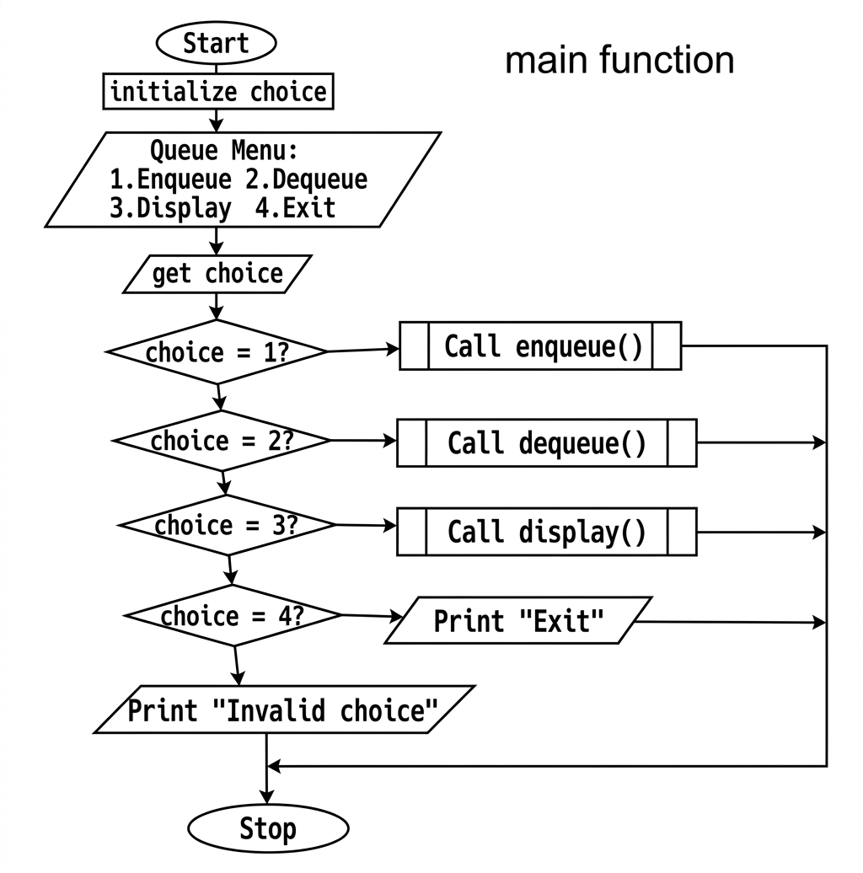

1.Enqueue
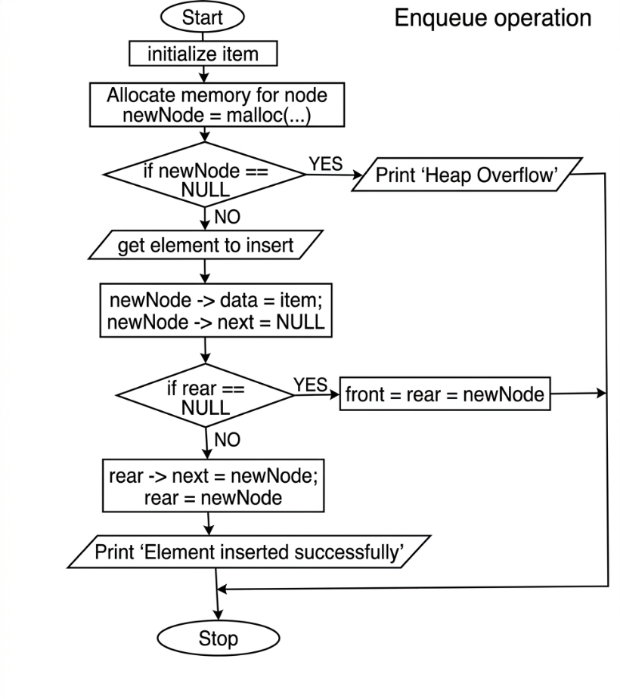

2.Dequeue
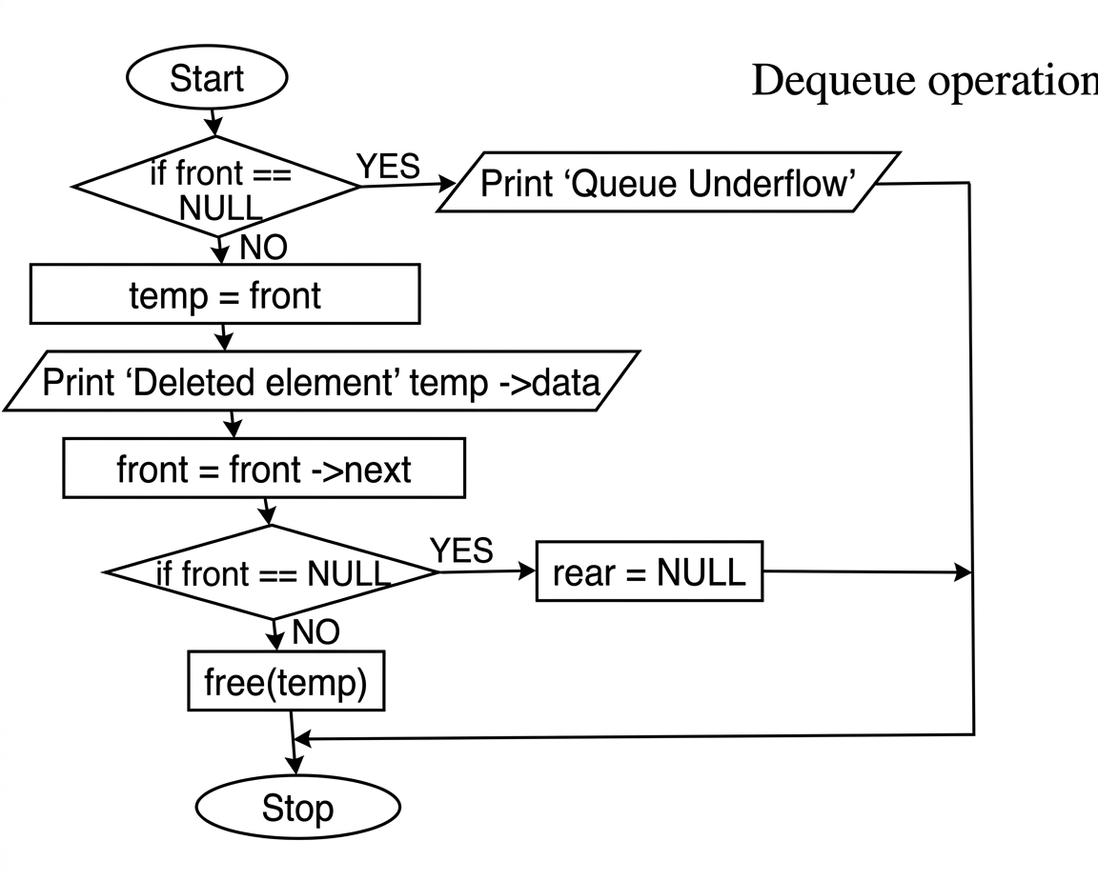

3.Display
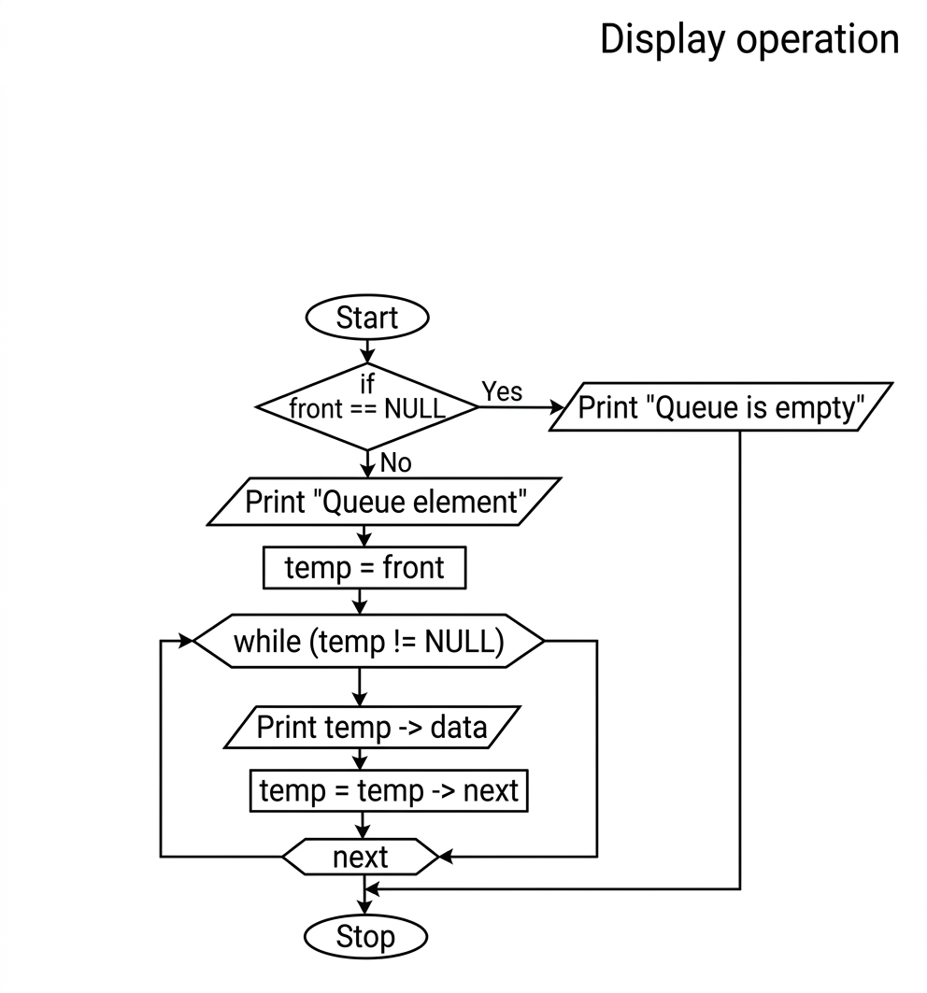

SOURCE CODE:
https://github.com/Harinhi26/dsalab/blob/main/Impliment%20Queue%20using%20Linked%20List.c
#include <stdio.h>
#include <stdlib.h>
// structure for queue node
struct node
{
int data;
struct node *next;
};
struct node *front = null;
struct node *rear = null;
// enqueue operation
void enqueue()
{
int item;
struct node *newnode;
newnode = (struct node *)malloc(sizeof(struct node));
if (newnode == null)
{
printf(“heap overflow!\n”);
return;
}
printf(“enter element to insert: “);
scanf(“%d”, &item);
newnode->data = item;
newnode->next = null;
if (rear == null)
{
front = rear = newnode;
}
else
{
rear->next = newnode;
rear = newnode;
}
printf(“element inserted successfully.\n”);
}
// dequeue operation
void dequeue()
{
struct node *temp;
if (front == null)
{
printf(“queue underflow!\n”);
return;
}
temp = front;
printf(“deleted element: %d\n”, temp->data);
front = front->next;
if (front == null)
rear = null;
free(temp);
}
// display queue elements
void display()
{
struct node *temp;
if (front == null)
{
printf(“queue is empty.\n”);
return;
}
printf(“queue elements:\n”);
temp = front;
while (temp != null)
{
printf(“%d “, temp->data);
temp = temp->next;
}
printf(“\n”);
}
int main()
{
int choice;
do
{
printf(“\n--- queue menu ---\n”);
printf(“1. enqueue\n2. dequeue\n3. display\n4. exit\n”);
printf(“enter your choice: “);
scanf(“%d”, &choice);
switch (choice)
{
case 1:
enqueue();
break;
case 2:
dequeue();
break;
case 3:
display();
break;
case 4:
printf(“exiting program.\n”);
break;
default:
printf(“invalid choice!\n”);
}
} while (choice != 4);

return 0;
}

SAMPLE OUTPUT;
--- Queue Menu ---
1. Enqueue
2. Dequeue
3. Display
4. Exit
Enter your choice: 1
Enter element to insert: 12
Element inserted successfully.

--- Queue Menu ---
1. Enqueue
2. Dequeue
3. Display
4. Exit
Enter your choice: 1
Enter element to insert: 51
Element inserted successfully.

--- Queue Menu ---
1. Enqueue
2. Dequeue
3. Display
4. Exit
Enter your choice: 3
Queue elements:
12 51

--- Queue Menu ---
1. Enqueue
2. Dequeue
3. Display
4. Exit
Enter your choice: 2
Deleted element: 12

--- Queue Menu ---
1. Enqueue
2. Dequeue
3. Display
4. Exit
Enter your choice: 3
Queue elements:
51

--- Queue Menu ---
1. Enqueue
2. Dequeue
3. Display
4. Exit
Enter your choice: 4
Exiting program.

